Practice 1 –Semiconductor diodes
Determine the current I₁, I₂ and I₃ for the network shown in Fig.1. Use simplified model for the diodes.
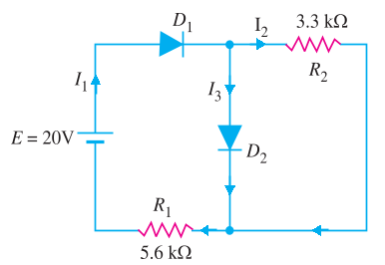Fig 1.

